**Senior Project Defense**

**Xecure Password Manager**

Student Name: Carlos R. Ocasio Rodriguez

Degree and Major: Bachelor of Science in Cybersecurity

Project Advisor Name: Prof. Henderson

Date: March 27, 2022

Expected Graduation Date: May 2022

**Problem Statement**

The management of passwords is one of the most important aspects of Cybersecurity and it is imperative that users implement and practice safe password management practices. In order to ensure safe password management practices users must create strong and unique passwords for every one of their accounts. User should then be able to log into all of their accounts in an efficient and effortless manner. Unfortunately, most users have far too many online accounts to remember a unique password for each account. A survey conducted by Nate Lord (2020) indicates that the average user has over 90 different online accounts. There is a limit to how many passwords a user can remember, and this survey revealed how the majority of users struggle with the number of passwords they manage, which usually leads to users reusing the same passwords. A Google Online Security Survey (2019) found that 52 percent of users reuse the same password for multiple accounts. The practice of reusing passwords leaves users vulnerable to intrusion attacks, which can result in data loss, monetary loss and more. A report conducted by IBM (2020) found that the average cost of a data breach is $3.68 million, while a data breach in the healthcare industry is estimated to cost around $7.13million. Furthermore, IBM found that data breaches in the United States are among the costliest averaging around $8.64 million.

By using a password manager users can easily manage unique passwords for their accounts while eliminating all the difficulties that are associated with complex passwords. With a password manager users can store all their passwords in a secured vault that can be accessed with a “master” password. This eliminates the need to remember multiple passwords and greatly reduces the chances of having multiple accounts compromised. The management of passwords is one of the most important and overlooked factors of information security. In order eliminate the difficulties that come with remembering passwords it is recommended that user utilize a password management application in order to protect their accounts.

**Project Description**

The project will be a password manager application for Windows computers used to securely store and manage log in information for various accounts. It will use a “master” password to provide access into the user’s account with all the passwords. The application will also be able to copy a record’s password into the computer’s clipboard. This password will then be wiped from the clipboard after fifteen seconds or if the user closes the application. The application will have connectivity to a MYSQL database that will be used to securely store the user’s information. In order to protect the information in the database the application will use the well-established AES encryption and SHA256 hashing algorithms. Additionally, the users will have the option to generate unique and complex passwords for every record entered. Users will also have the option of entering their own passwords and the application will guide them every step of the way. Lastly, the program will have features that allows users to reset their “master” password and email if they forget it or wish to change it.

The application will be called Xecure Password Manager and it was inspired by applications like KeePass, and LastPass and it contains all of the major features that these application have. All of the previously mentioned features are the standard in the password manager market, and they will be included in the Xecure Password Manager application at no cost to the users. In addition to being a free application, Xecure Password Manager will not contain any ads, there are no password or account limits, and it will not store or use user data for any other purpose. This is what separates Xecure Password Manager from the competition.

**Personal Motivation**

The practice of securing networks, systems and other digital infrastructures are an essential aspect to information systems and cybersecurity. As a Cybersecurity major, I strive to broaden these previously mentioned technical and functional skills. The development of this application will provide me with a deeper understanding of various hashing and encryption practices that are vital to the field of cybersecurity. It will also strengthen my problem solving and debugging skills that are necessary as a programmer. The program will also require an understanding of the various methods that attackers used to exploit passwords. This will expand my computer analysis skills and provides me with additional resources and solutions that can be used to thwart malicious attacks. By creating this application and developing the previously mentioned skills I will be able to set myself apart from the competitions and I will be able to demonstrate my expertise as a cybersecurity professional.

**Research & Background**

The project will be completed by utilizing the previously attained skills during my academic development at CSU. The first phase of the project involves researching and testing of various features. This is important as it will reveal what the requirements for the applicating should be and it will determine what features are not feasible for the scope of this project. The second phase involves identifying requirements and developing the requirements document. At this stage the specifics of the project will be described and a document with the requirements will be drafted. This document will identify the main functions of the program and will establish the scope of the project. After this document is created some research will have to be conducted in order to begin the prototype construction phase. The research will determine how the design of the program should be implemented. The research will involve observations and studying similar applications. After this is done a prototype will be constructed along with all of its documentation. After conducting some additional research, a high-fidelity prototype will be constructed. The design of the final product will be constructed based on the feed-back from this high-fidelity prototype. The final phase involves testing the functionality and security of the application.

A functional password manager application will be presented along with all of the relevant documented information. The documents include Requirement’s document, Prototype documents, Final Prototype documents, Test cases document.

**Proposed Implementation Languages**

The password manager application was developed on a Windows computer by using the latest versions of Python 3 (version 3.9.7) and MySQL (version 8).

**Libraries, packages, development kits**

The password manager application will use the following libraries:

* Hashlib – Used for hashing.
* cryptography.fernet – Used to encrypt.
* msvcrt – Used to prevent the command screen from continuing until a key is pressed.
* mysql.connector – Used to connect to the database.
* os – Used to change the title of the command line screen.
* Sys – Used alongside getpass to hide passwords in the command line screen.
* getpass – Used to hide password in the command line screen.
* random – Used to generate random passwords and codes.
* smtplib – Used for emailing capabilities.
* socket – Used alongside smtplib to send emails, and email error handling.
* time – Used alongside pyperclip to determine when to wipe clipboard.
* pyperclip – Used to save record’s password into the computer’s clipboard.
* threading – Used to wipe the clipboard while the user continues to use the application.

Top of Form

Bottom of Form

Top of Form

Bottom of Form

**Additional Software/Equipment Needed**

A Windows operating system is required, as well as Python (version 3.9.7) and a MySQL (version 8) database. See below for instructions on how to download and setup both Python and MySQL.

**MySQL Installation Guide:**

These steps will guide you through the installation and setup of the MySQL Community Server for the required database of this application.

1. Visit <https://dev.mysql.com/downloads/mysql/>
2. Look for the “MySQL (MSI) Installer for Windows” and click on the “Go to Download Page” button (You can also use this link: <https://dev.mysql.com/downloads/windows/installer/8.0.html>)
3. There will be two Windows MSI Installer options here. Please find the “(mysql-installer-community-8.0.27.0.msi)” option and press the download button.
4. You will be redirected to a screen that asks you to login or sign up, but this is not needed. Scroll down to the bottom of the page and click on the “[No thanks, just start my download.](https://dev.mysql.com/get/Downloads/MySQLInstaller/mysql-installer-community-8.0.27.0.msi)” link.
5. A download prompt will be displayed. Click on the “Save File” button. This will start the download of the file.
6. Wait for the download to finish.
7. Once it has downloaded, look for the “mysql-installer-community-8.0.26.0” (version number might change) file and run it. The file is typically located in your downloads folder.
8. After double clicking the file, it will begin preparing the installation and it will then ask you for permission to install the application. Click the “yes” button.
9. It may ask you “Do you want to allow this app to make changes to your pc?”. Click on the “yes” button. (Skip this step if you did not see this alert)
10. The MySQL installation windows will now be displayed, and it will ask you to read over the License Agreement. After doing so, press the “I accept the license terms” check box and press the “Next” button.
11. On the “Choosing a Setup Type” screen select the “Developer Default” option and press next.
12. A screen may alert you that some product requirements have not been satisfied and it will ask you if you wish to continue. Select yes. (Skip this step if you did not see this alert)
13. On this installation screen you can see all of the products that will be installed. When you are ready select the “Execute” button. This will begin installing all of the products.
14. Wait for the Installation to finish.
15. After the download has finished you will see a green checkmark on all of the products downloaded. If everything downloaded successfully press the “Next” button.
16. On the “Product Configuration” screen you will be able to see the configuration for all of your downloaded products. Once you have reviewed this information press the “Next” button.
17. On the “Type and Networking” screen select the “Standalone MySQL Server/Classic MySQL Replication” option and press the “Next” button.
18. On this screen leave the “Config Type” as “Development Machine”. Make sure that the “TCP/IP” checkbox and “Open Firewall port for network access” checkbox are selected. Lastly, the “Port Number” is 3306. After confirming these options press the “Next” button.
19. On the Accounts and Roles screen enter a strong password on the “MySQL Root Password” fields (**make sure you remember this password**). Then press the “Add User” button to create a user account.
20. A screen will appear and ask you for username information. Enter a username for your account (**make sure you remember this username**). Then enter a strong password for your account (**make sure you remember this password**). Once this is done press the “Ok” button. After creating your user account press on the “Next” button.
21. On the “Windows Service” screen leave all settings as default and press on the “Next” button.
22. On the “Plugins and Extensions” screen leave all settings as default and press on the “Next” button.
23. On the “Apply Configuration” screen you will see an overview of the configurations. Once you are ready press the “Execute” button and the listed changes will be applied. Once this is done press the “Finish” button.
24. On the “Product Configuration” Screen you will see that the MySQL Server is completed. Press the “Next” button to continue.
25. On the “MySQL Router Configuration” screen you will leave all settings as default and press on the “Next” button.
26. On the “Product Configuration” screen you will review the configuration and press on the “Next” button.
27. On the Connect To Server screen, select the “MySQL Server 8.0.27.0 (version may be different for you) text. Then enter press the “Check” button to test the connection. Once the connection is established and you see a “Connection Successful” message press the “Next” button.
28. On the apply configurations, press the “Execute” button. Once all the configurations are finished press the “Finish” button.
29. On the “Product Configuration” screen you will review the configuration and press on the “Next” button.
30. You will see the installation complete screen. Press the “Finish” button.
31. You have successfully installed the MySQL database.

**To use with MySQL Workbench:**

1. Go to start and search for “workbench”
2. Open the MySQL Workbench
3. Once the application opens, double click the “Local instance” below the “MySQL Connections”.
4. A screen will appear, and you will be prompted to enter the password for the database. After entering the password, press the “OK” button.
5. This is your database serve.

**Requirements**

Requirement ID Number: 1 Requirement Type: 1, 2 (Functional, Look and Feel)

Description: The application will have a command-line-based user interface.

Rationale: An interface will be needed so that users can interact with the application in an efficient and simple manner. A broader audience will be able to use the application if a command-line-based user interface is implemented.  
Fit Criterion: Users must be able to use all features and accomplish all tasks by using the command-line-based interface.

Priority: Very High  
Dependencies: None

Requirement ID Number: 2 Requirement Type: 1, 6 (Functional, Security)

Description: A login section must be implemented.

Rationale: The login section is needed to authenticate users and grants them access to their data.   
Fit Criterion: When presented with valid credentials the application must authenticate users and grant them access to their data. If presented with invalid credentials, the application will display an error message and will not grant them access to the data. Users will not be able to get past the login screen without valid credentials.

Priority: Very High  
Dependencies: None

Requirement ID Number: 3 Requirement Type: 1, 6 (Functional, Security)

Description: The application must have connectivity to a MYSQL database.

Rationale: The database provides storage and security features.

Fit Criterion: The application must be able to save data to the database. The data will be inaccessible if there is no database connectivity. Additionally, it will not allow the user to create a record if the database cannot be reached.

Priority: Very High  
Dependencies: None

Requirement ID Number: 4 Requirement Type: 6 (Security)

Description: The application must store user records in the MYSQL database.

Rationale: The database provides storage and security features. It also provides features against data redundancy and reduces inconsistencies. All these features are important for managing log-in credentials.

Fit Criterion: The application must be able to save data to the database. This data must then be accessible to authorized users only. An error message will alert the user if the data was not saved to the database.

Priority: Very High  
Dependencies: The application must have connectivity to the database for this requirement to be fulfilled.

Requirement ID Number: 5 Requirement Type: 1, 6 (Functional, Security)

Description: A “Register” section must be implemented.

Rationale: Users need to be able to create an account to use the application. Therefore, a “Register” section must be implemented.

Fit Criterion: The “Register” section must allow users to create a master username and password. If correctly done the username and password will be stored in the database. These credentials can then be used to log in to the application. Users cannot use the application without creating an account.

Priority: Very High  
Dependencies: A “Login” section and the database must be implemented before this requirement can be fulfilled.

Requirement ID Number: 6 Requirement Type: 6 (Security)

Description: Application will lock-out an account after six failed log-in attempts and the password will be reset.

Rationale: Unauthorized users may attempt to guess the login credentials of a user. To prevent these brute force attacks a lock-out feature will be implemented.

Fit Criterion: After six failed log-in attempts the application will place a lock on the account and the user will not be able to log in. The lock-out feature will cause the application to force close.

Priority: Very High  
Dependencies: The “Login” section and the “Register” section must be implemented before this requirement can be fulfilled.

Requirement ID Number: 7 Requirement Type: 6 (Security)

Description: All data stored and used by the application must only be accessible to authorized users.

Rationale: The data stored and used by the application must only be visible to authorized users. To prevent a data breach, registered users will only have access to their data. Users that are not registered will not be able to use the application and will not have access to any data.

Fit Criterion: Registered users must only be able to see their data, while unregistered users will not be able to use the application.

Priority: Very High  
Dependencies: The “Login”, “Register”, and database sections must be implemented before this requirement can be fulfilled.

Requirement ID Number: 8 Requirement Type: 6 (Security)

Description: A SHA256 hash will be used as a log-in authentication method.

Rationale: In order to improve security, the username and password along with a hashing algorithm will be used to authenticate the user.

Fit Criterion: The SHA256 will be used to hash the username and password provided. If the username and password provided match the login credential stored in the database, the user will be authenticated, and access will be granted. If the hash does not match the login credential stored in the database access to the application will be denied.

Priority: Very High  
Dependencies: The “Login”, “Register”, and database sections must be implemented before this requirement can be fulfilled.

Requirement ID Number: 9 Requirement Type: 3, 6 (Usability, Security)

Description: The application must be able to generate random passwords.

Rationale: Users may need help creating secure passwords. The application will provide them with the option of generating a strong random password for their desired account.

Fit Criterion: A random password must be generated and displayed to the user after opting for this feature. An error will alert the user if the random password was not generated.

Priority: Medium  
Dependencies: None

Requirement ID Number: 10 Requirement Type: 3, 6 (Usability, Security)

Description: The application will allow users to create their own password.

Rationale: Users may not like having randomly generated passwords. They may want to use their own passwords.

Fit Criterion: Users must be able to enter their own passwords. A confirmation message will alert the user that their password was accepted and saved.

Priority: High  
Dependencies: The “Login”, “Register”, and database sections must be implemented before this requirement can be fulfilled.

Requirement ID Number: 11 Requirement Type: 3, 6 (Usability, Security)

Description: The rules for the record passwords cannot be strict

Rationale: The application cannot dictate what users have chosen in the past for their passwords. It must accept all kinds of passwords no matter how weak or strong.

Fit Criterion: Any password less than thirty-five characters long will be accepted as a record password. The user will be notified if the password was saved successfully/

Priority: High  
Dependencies: The “Login”, and “Register” sections must be implemented before this requirement can be fulfilled.

Requirement ID Number: 12 Requirement Type: 3 (Usability)

Description: Simple controls must be implemented on the front end to send SQL queries to the database.

Rationale: Users do not want to create SQL queries for every task while using the application.

Fit Criterion: Queries will be created in the back end and the users must be able to utilize them on the front end. Users must be able to view, add, edit, and delete records on the database from the front end. A confirmation message will be displayed after a successful query.

Priority: High  
Dependencies: The “Login”, and “Register” sections must be implemented before this requirement can be fulfilled.

Requirement ID Number: 13 Requirement Type: 3 (Usability)

Description: User data stored in the database will be encrypted by using fernet (AES 256) encryption.

Rationale: Encrypting the data prevents unauthorized users from using it. Encryption increases the security of the application and protects the data of the users.

Fit Criterion: No plaintext must be visible in the database. If plaint text is found in the database this requirement has not been fulfilled. The information in the database must be decrypted before it can be used. If an encryption attempt fails an error message will be displayed to the screen.

Priority: Very High  
Dependencies: The database must be implemented before this requirement can be fulfilled.

Requirement ID Number: 14 Requirement Type: 3, 6 (Usability, Security)

Description: Registered users must be able to retrieve their unencrypted data from the database.

Rationale: Users need to be able to see their saved login credentials. They may want to view them before changing or deleting the credential.

Fit Criterion: Users must be able to select a specific account to retrieve their unencrypted password. If the data retrieved data is encrypted this requirement has not been fulfilled. If the data cannot be retrieved or if it cannot be unencrypted an error message will be displayed to the user.

Priority: High  
Dependencies: The database and the encryption algorithm must be implemented before this requirement can be fulfilled.

Requirement ID Number: 15 Requirement Type: 3 (Usability)

Description: Passwords retrieved from the database must be copied to the user’s clipboard.

Rationale: This is done so that the user can immediately use the password as it is automatically placed in their clipboard. After retrieving the password users can paste it into their desired field.

Fit Criterion: After retrieving the data the user must be able to use the “paste” command and the password will be “pasted” into their desired field. An error message will be displayed if the password was not placed in the clipboard. On the other hand, a confirmation message will be displayed if the password was placed into the user’s clipboard.

Priority: Low  
Dependencies: The “Login”, “Register”, database and encryption sections must be implemented before this requirement can be fulfilled.

Requirement ID Number: 16 Requirement Type: 3 (Usability)

Description: The application must guide and direct users on how to accomplish all tasks.

Rationale: Users may not understand how to use the application. Clear and concise instructions will help the user navigate the application.

Fit Criterion: Prompts and alerts will guide the user on how to accomplish their task. The success of the direction will be based on task completion time. The average task completion time should be under five minutes.

Priority: Medium  
Dependencies: The “Login”, “Register”, database, and encryption sections must be implemented before this requirement can be fulfilled.

Requirement ID Number: 17 Requirement Type: 3 (Usability)

Description: The users must be able to go back to the previous menu at any point of the process.

Rational: The users may decide they wants to cancel their current action.

Fit Criterion: A back option must be present in every part of the application. Once the option has been selected an alert message will prompt the user to confirm the action. The user will be taken back to the previous screen.

Priority: Medium  
Dependencies: The “Login”, “Register”, database and encryption sections must be implemented before this requirement can be fulfilled.

Requirement ID Number: 18 Requirement Type: 6 (Security)

Description: The users must be able to log out of the application.

Rational: The users need to be able to log out of the application in a secure manner.

Fit Criterion: Once the option has been selected an alert message will prompt the user to confirm the action. The user will be logged out of the application if they confirm the action.

Priority: Very High  
Dependencies: The “Login”, “Register”, database, and encryption sections must be implemented before this requirement can be fulfilled.

Requirement ID Number: 19 Requirement Type: 3 (Usability)

Description: The users must be able to create, view, edit, and delete records from their account.

Rational: Users need to have full control over their data. They may want to create new records or delete old ones.

Fit Criterion: A confirmation message will be displayed if the action selected was completed successfully. On the other hand, if one of these actions cannot be completed an error message will be displayed to the user.

Priority: Very High  
Dependencies: The “Login”, “Register”, database and encryption sections must be implemented before this requirement can be fulfilled.

Requirement ID Number: 20 Requirement Type: 6 (Security)

Description: Passwords that are considered too weak will not be accepted as the master password.

Rational: Short passwords or passwords that are considered too weak will not be accepted as the master password as this is a security risk.

Fit Criterion: A message will alert the user if their password is too weak. They will also not be able to save their password and will be asked to come up with a new one. Once a strong enough password has been entered a confirmation message will be displayed to the screen.

Priority: Very High  
Dependencies: The “Login”, “Register”, database and encryption sections must be implemented before this requirement can be fulfilled.

Requirement ID Number: 21 Requirement Type: 6 (Security)

Description: Input validation must be performed throughout every section of the application.

Rational: Users may enter invalid data accidentally or purposefully and thus every input must be properly validated and sanitized to prevent a security risk. All prompts will be validated and will include exceptions to handle all scenarios.

Fit Criterion: All invalid inputs will produce an error message that will be displayed to the screen.

Priority: Very High  
Dependencies: The “Login”, “Register”, database and encryption sections must be implemented before this requirement can be fulfilled.

Requirement ID Number: 22 Requirement Type: 3 (Usability)

Description: Error messages must provide guidance on how to complete the task.

Rational: Users may not understand why they can’t proceed and may need help fixing their mistakes.

Fit Criterion: The error messages must provide clear and concise instruction on how to complete the current task. The success of the direction will be based on task completion time. The average task completion time should be under five minutes.

Priority: Low  
Dependencies: The “Login”, “Register”, database, and encryption sections must be implemented before this requirement can be fulfilled.

Requirement ID Number: 23 Requirement Type: 6 (Security)

Description: The application must have measures in place to prevent SQL injection attacks.

Rational: Unauthorized users may attempt to use an SQL injections to get access to the data.

Fit Criterion: Inserting SQL injections will result in an invalid input error.

Priority: Very High  
Dependencies: The “Login”, “Register”, database, and encryption sections must be implemented before this requirement can be fulfilled.

Requirement ID Number: 24 Requirement Type: 6 (Security)

Description: The average user should be able to retrieve a password in under three minutes.

Rational: Users typically do not want to use application that take too long to complete a task.

Fit Criterion: Users must be able to retrieve a password in under three minutes.

Priority: Medium  
Dependencies: The “Login”, “Register”, database, and encryption sections must be implemented before this requirement can be fulfilled.

Requirement ID Number: 25 Requirement Type: 6 (Security)

Description: The application must have emailing capabilities in order to reset passwords.

Rational: The application may need to send emails to the users. To reset passwords, the application will require emailing capabilities.

Fit Criterion: Application must be able to send emails to the users. Once the email has been sent a confirmation message will be displayed to the screen.

Priority: Medium  
Dependencies: The “Login”, “Register”, database, and encryption sections must be implemented before this requirement can be fulfilled.

Requirement ID Number: 26 Requirement Type: 6 (Security)

Description: A verification code must be sent to the users email in order to verify their account.

Rational: Users may forget their password and may need to change their password/email. Before doing so, users must verify their account by entering the code sent to their email.

Fit Criterion: Users must enter the correct code before they can change their password/email. If the entered code does not match the user will be given an error message. If the code matches, they will be able to change their password/email.

Priority: Very High  
Dependencies: The “Login”, “Register”, database, emailing and encryption sections must be implemented before this requirement can be fulfilled.

Requirement ID Number: 27 Requirement Type: 6 (Security)

Description: Errors in the middle of data entry will display an error and no data will be saved to the database.

Rational: This requirement will prevent the application from saving invalid or incomplete data into the database. The error will inform the user what went wrong and how to fix the problem.

Fit Criterion: An error message will be displayed if something goes wrong in the middle of data input. The user will have to acknowledge the error before moving on.

Priority: High  
Dependencies: The “Login”, “Register”, database, and encryption sections must be implemented before this requirement can be fulfilled.

Requirement ID Number: 27 Requirement Type: 6 (Security)

Description: Clipboard will be cleared after fifteen seconds.

Rational: The clipboard can be exploited to retrieve personal detail. Thus, the clipboard must be wiped after fifteen seconds.

Fit Criterion: After fifteen seconds the user will no be able to paste their password. Trying to paster will result in a empty result.

Priority: Very High  
Dependencies: The “Login”, “Register”, clipboard, database, and encryption sections must be implemented before this requirement can be fulfilled.

Requirement ID Number: 28 Requirement Type: 6 (Security, Usability)

Description: Users must be able to retrieve their username

Rational: Users may forget their username.

Fit Criterion: Users should be able to retrieve their username by verifying their email account. After this verification an email will be sent to the user with their registered email address.

Priority: Very High  
Dependencies: The “Login”, “Register”, clipboard, database, and encryption sections must be implemented before this requirement can be fulfilled.

Requirement ID Number: 28 Requirement Type: 6 (Usability)

Description: Users must be able to display only the name of their record names.

Rational: Users may not want to display all of the information of all of their records, and thus they should be able to retrieve only the record names. This name can then be used to retrieve the specific record information.

Fit Criterion: Users should be able to see all of their record names through the “Retrieve Record Names Only” screen. No record names will be seen if the database is empty.

Priority: Very High  
Dependencies: The “Login”, “Register”, clipboard, database, and encryption sections must be implemented before this requirement can be fulfilled.

Requirement ID Number: 29 Requirement Type: 6 (Usability)

Description: The application cannot be accessed if there are no registered users.

Rational: The application should not be accessible if no user has registered.

Fit Criterion: A “Database is empty! Please register to use the application.” message will be displayed if no user has registered.

Priority: Very High  
Dependencies: The “Login”, “Register”, database, and encryption sections must be implemented before this requirement can be fulfilled.

Requirement ID Number: 30 Requirement Type: 6 (Usability)

Description: Users should be able to delete all of their records.

Rational: Users should have an option to delete all of their records stored in the database. They should not have to do it one at a time.

Fit Criterion: All records must be deleted from the database and application if the user selects and confirms the “Delete all records” option.

Priority: Very High  
Dependencies: The “Login”, “Register”, delete all, database, and encryption sections must be implemented before this requirement can be fulfilled.

Requirement ID Number: 31 Requirement Type: 6 (Security)

Description: All SQL statements will be composed of prepared statements

Rational: Using prepared statement protects the application from SQL injections.

Fit Criterion: Users should not get any information when attempting to perform SQL injections.

Priority: Very High  
Dependencies: The “Login”, “Register”, database, and encryption sections must be implemented before this requirement can be fulfilled.

**Additional Requirements:**

**Securing Database (Security)**

In order to secure the database and the information within it, access into the database will be limited and will require a password to authenticate. Ideally only the root user will have control and access to the database. Other accounts will need well defined rules for database access, Views access, and data storing procedures based on needs and the role of the individuals. To protect the information within the database, all the data will be encrypted before being stored in the database. In order to prevent unauthorized connections into the database, access will be limited to local host. Additionally, in order to prevent SQL injections, all queries will be pre-defined within the application, and then the parameters will be passed on to the query after being sanitized. This will validate the user input and prevent users from creating their own queries.

**Clipboard Vulnerability (Security)**

All password manager applications utilize the Windows clipboard to allow users to copy and paste a specified account password. This is a convenient feature as it prevents users from having to type long and complicated passwords, but it can also be exploited if the computer was infected with malware. When the password is copied into the clipboard this data is temporarily stored in the memory of the computer. The longer the password kept in the clipboard the longer it will be stored in memory. This creates a window of opportunity for an attacker to access your system and retrieve the password from the clipboard or the memory of the computer. To prevent this from happening password managers flush the clipboard after a certain amount of time has passed. A feature like this will be created and implemented in this password manager. The application will alert the user that the password will be wiped from the clipboard after fifteen seconds of retrieving the password. The user may retrieve the password again if he needs it after the first fifteen seconds. In addition to clearing the clipboard after fifteen seconds, it will also be cleared when the user logs out, and lastly when the user exits the application. This feature will not completely prevent this vulnerability, but it will reduce the probability of it happening and it is the industry standard.

**Project Description**

The initial setup of the application consists of adding the username and password of your MYSQL database. To do this user’s need to edit the database.py file and add their username on line four, and then the password on line five. For more details, please see the example below:

Line 4: 'user': 'root',

Line 5: 'passwd': '12345',

*Note: Replace “root” with your username and “12345” with your password*.

After adding the username and password to the database.py file, the application is ready for use. Once the application is executed….

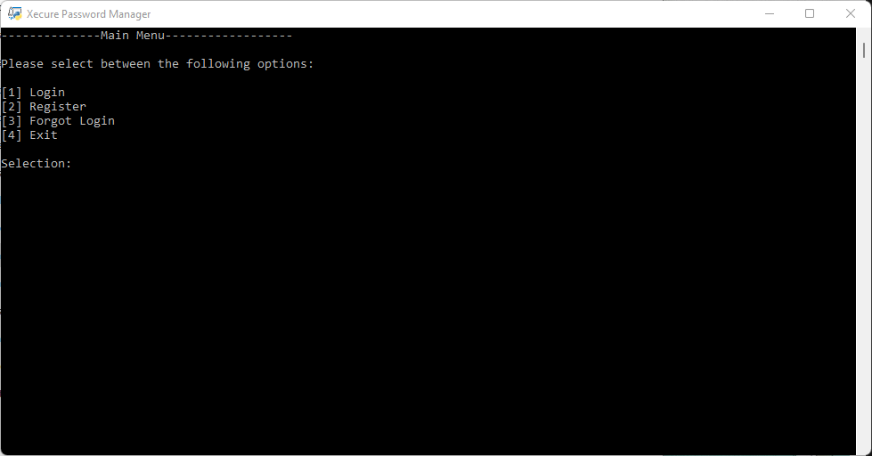

Figure 1: Main Menu Screen

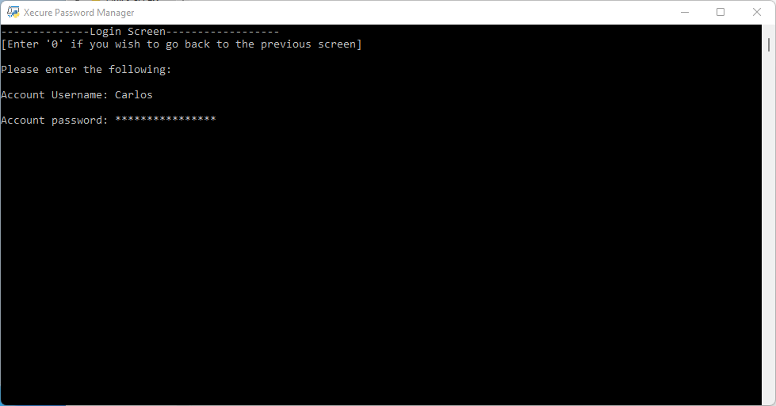

Figure 2: Login Screen

Figure 3: Register Screen

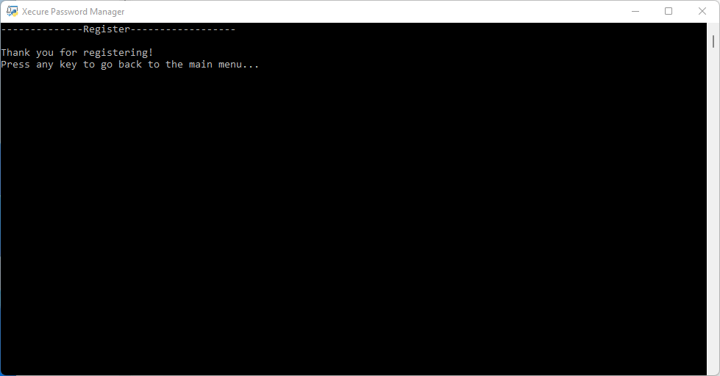

Figure 4: Successful Registration Screen

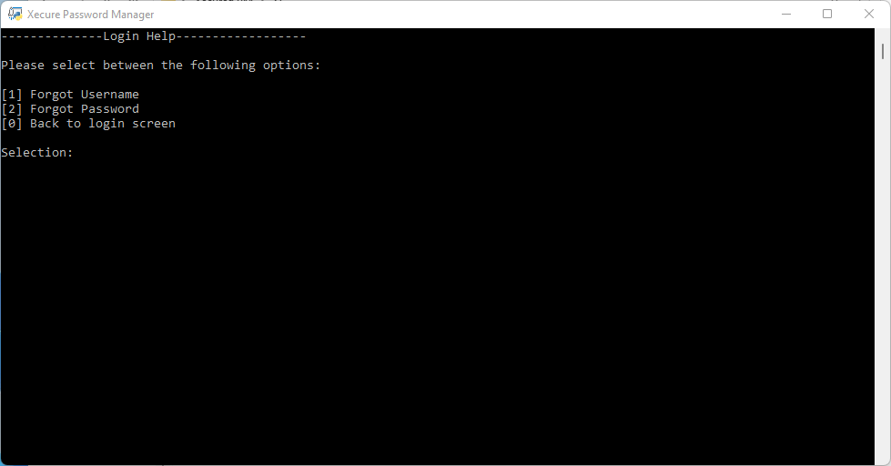

Figure 5: Login Help Screen

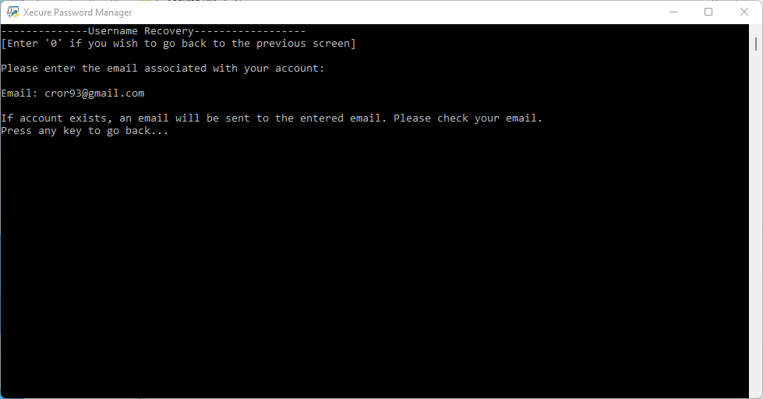

Figure 6: Username Recovery Screen

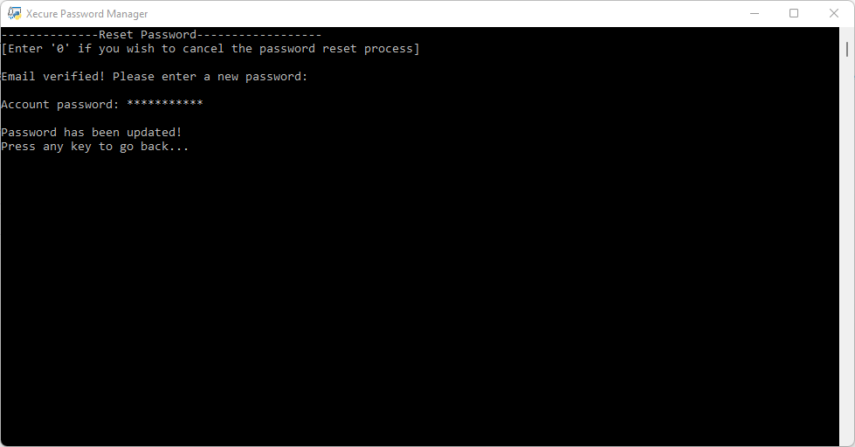

Figure 7: Reset Password Screen

Figure 8: Dash Board Screen

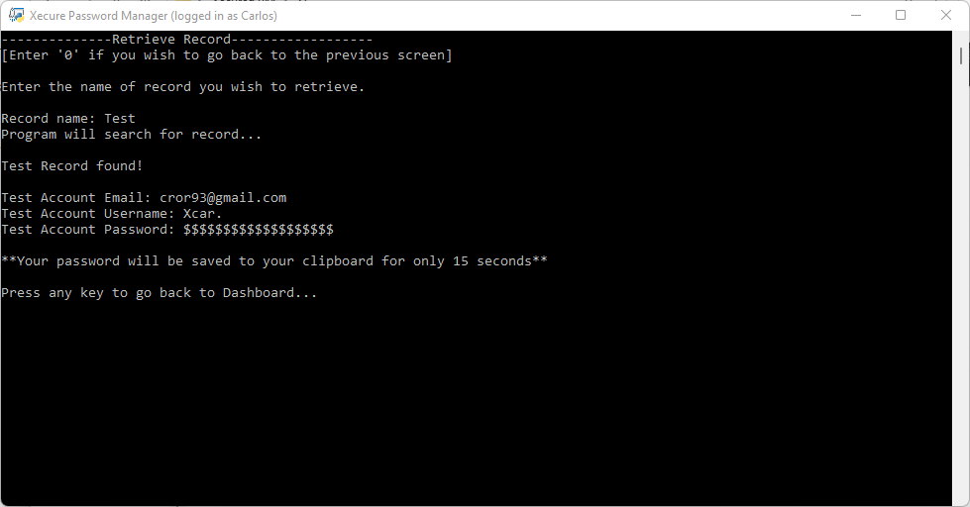

Figure 9: Retrieve Record Screen

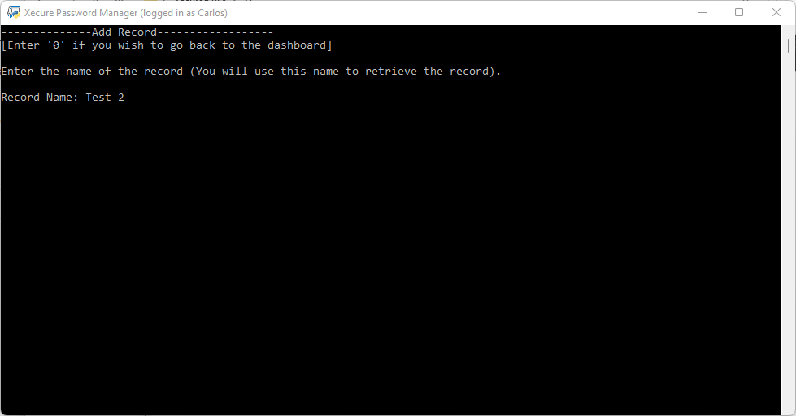

Figure 10: Add Record Screen

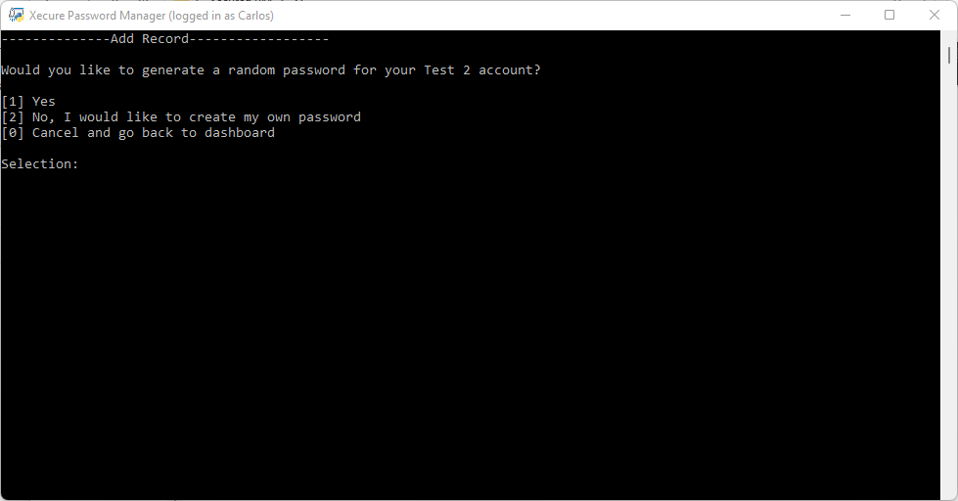

Figure 11: Add Record – Generate Random Password Screen

Figure 12: Generate Random Password Screen

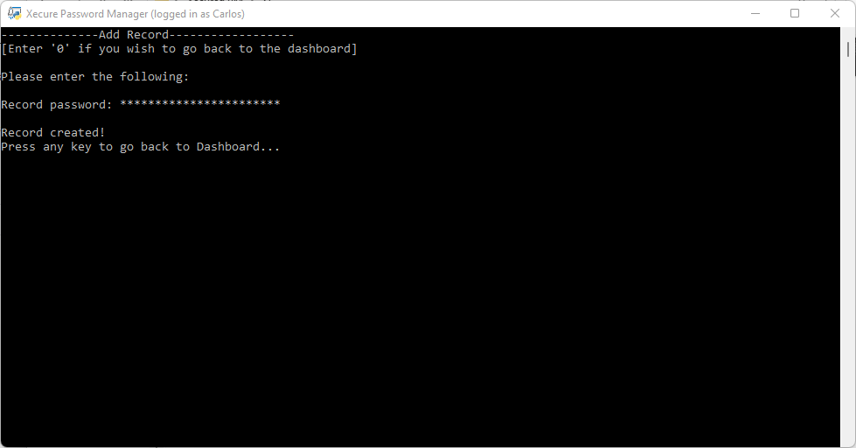

Figure 13: Enter Your Password Screen

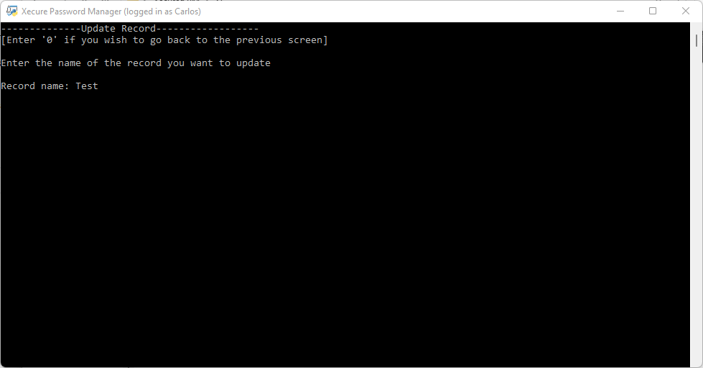

Figure 14: Update Record Screen

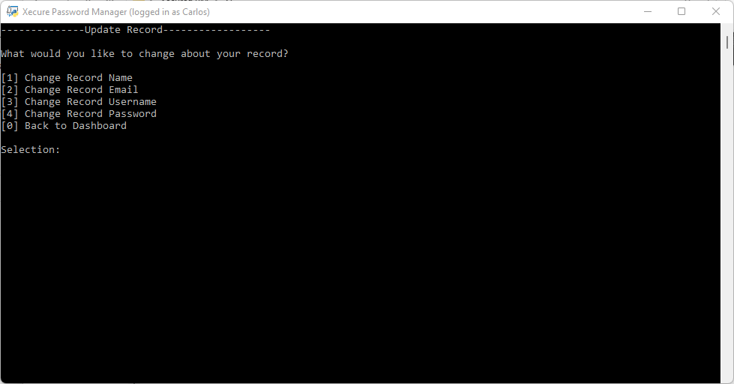

Figure 15: Update Record Screen

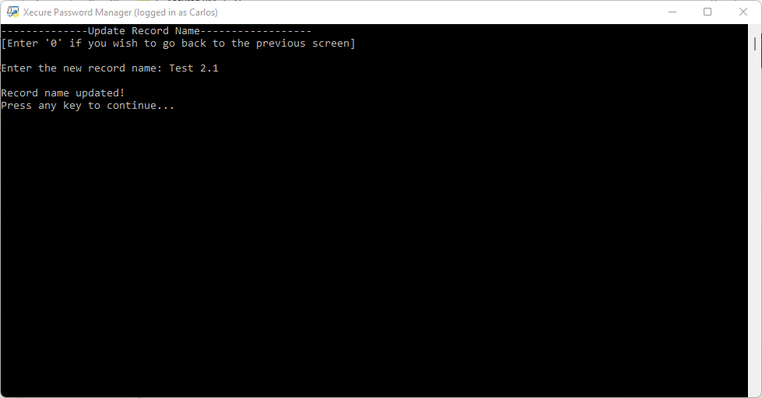

Figure 16: Updating Record Name Screen

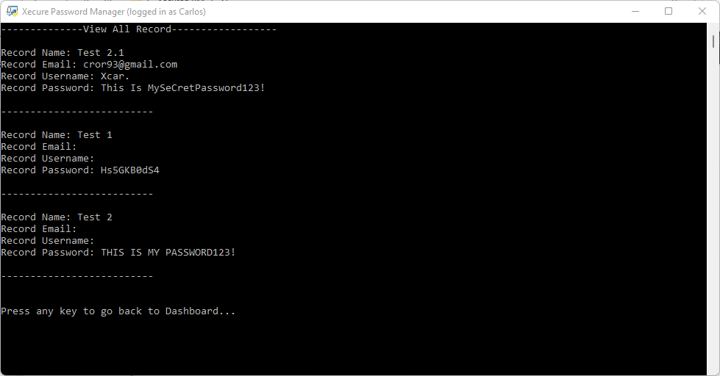

Figure 17: View All Records Screen

Figure 18: View All Record Names Screen

Figure 19: Settings Screen

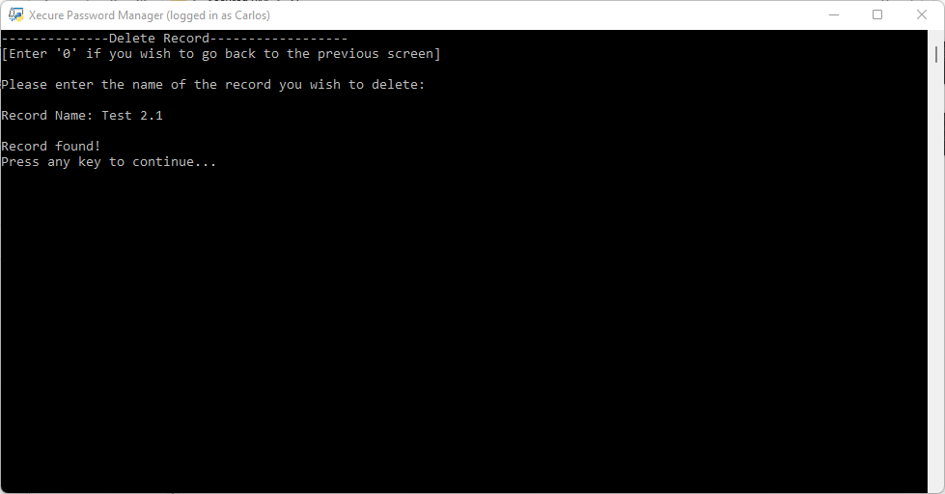

Figure 20: Delete Record Screen

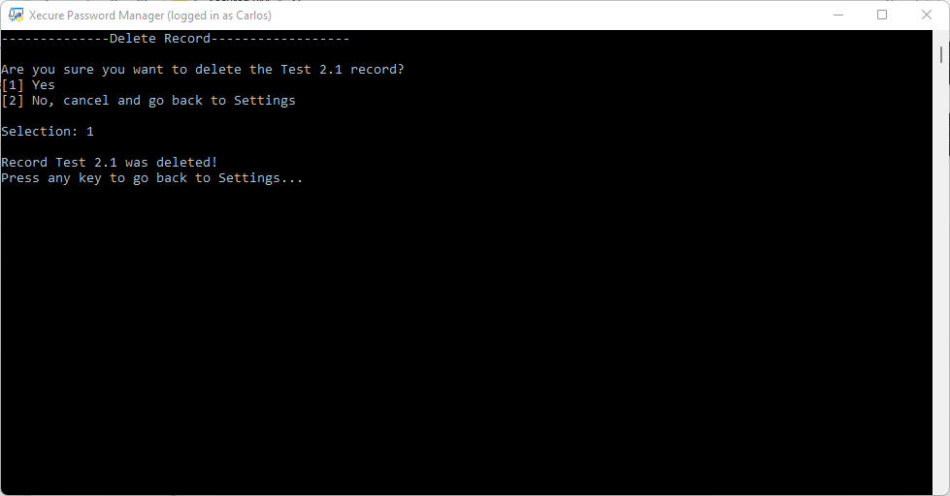

Figure 21: Deleting A Record

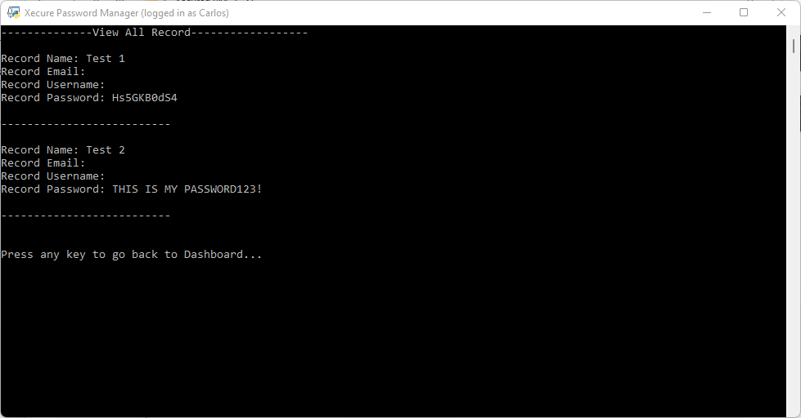

Figure 21: View All Screen After Deleting Record

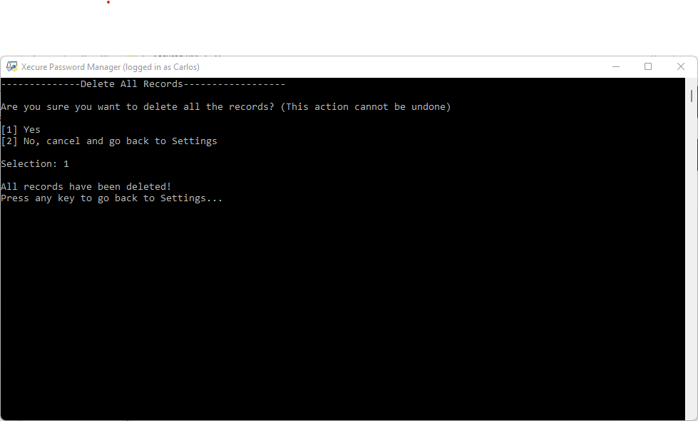

Figure 23: Delete All Records Screen

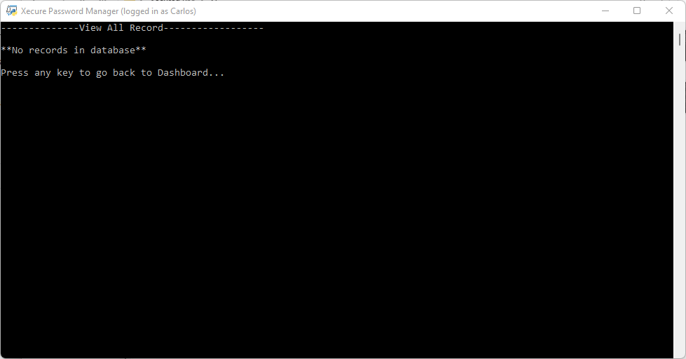

Figure 24: View All Records After Deleting All Records

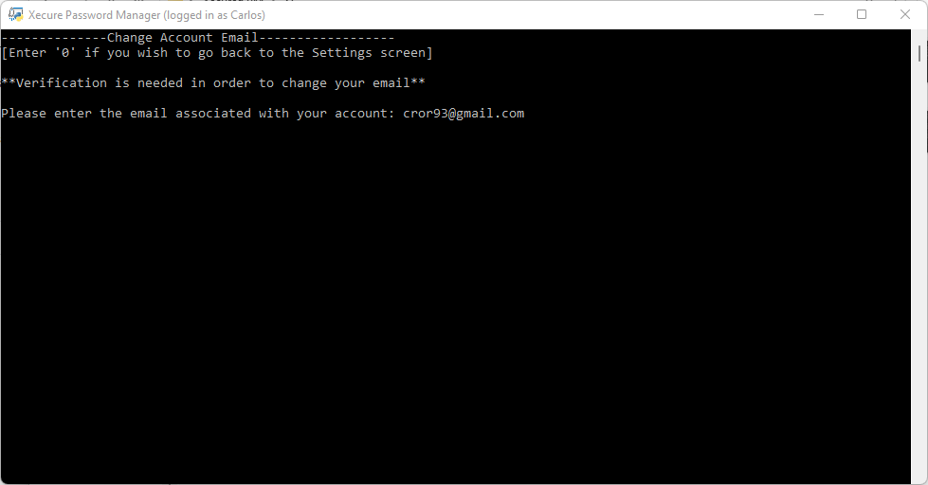

Figure 25: Change Account Email Screen

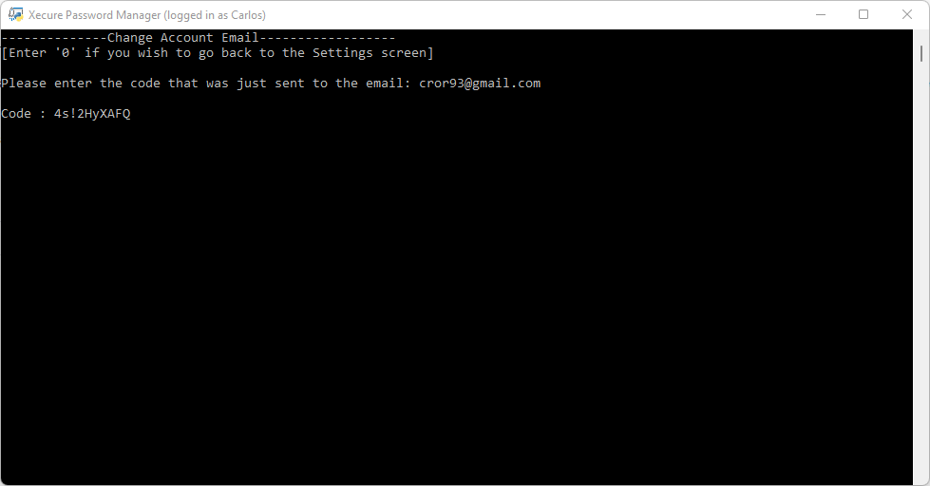

Figure 26: Change Account Email Screen – Verification Code

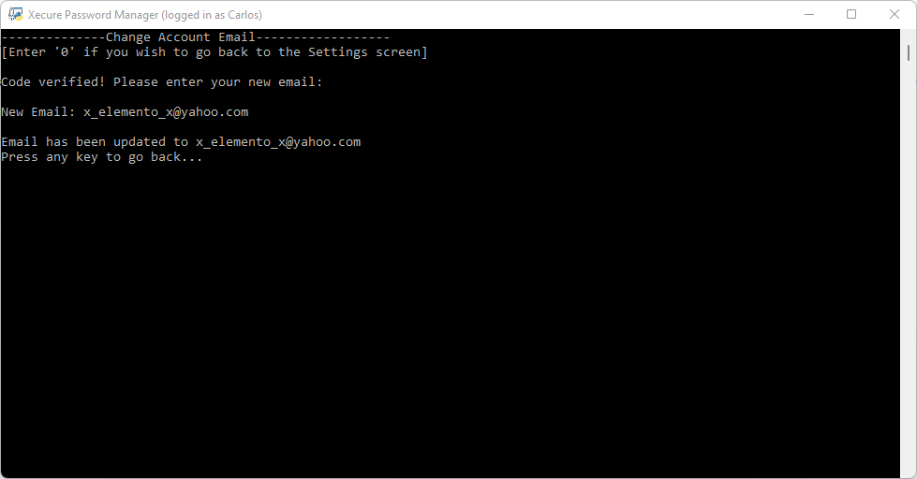

Figure 27: Updating Account Email

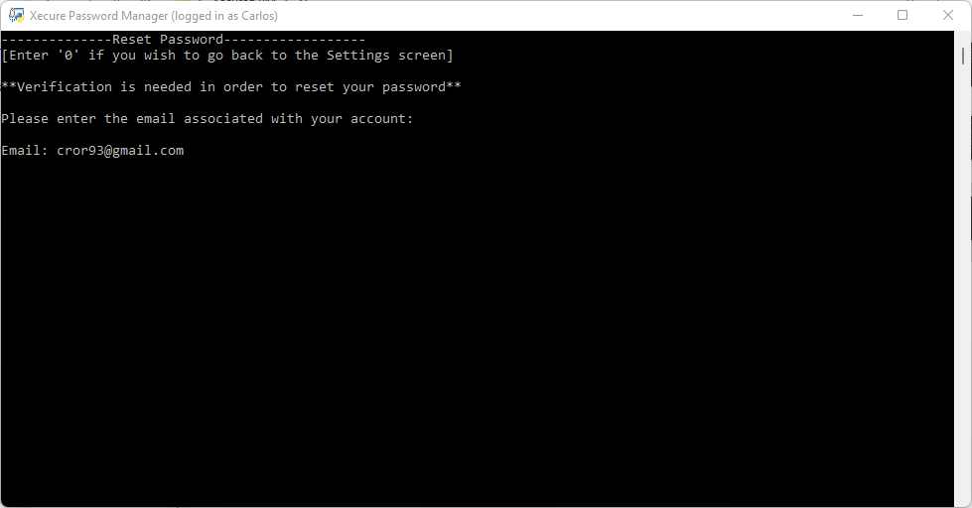

Figure 28: Reset Password Screen

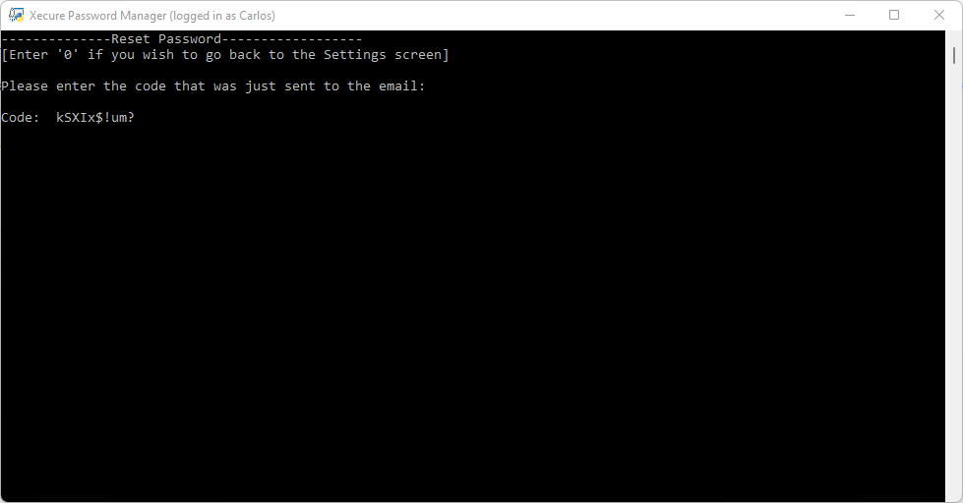

Figure 29: Reset Password Screen – Verification Code

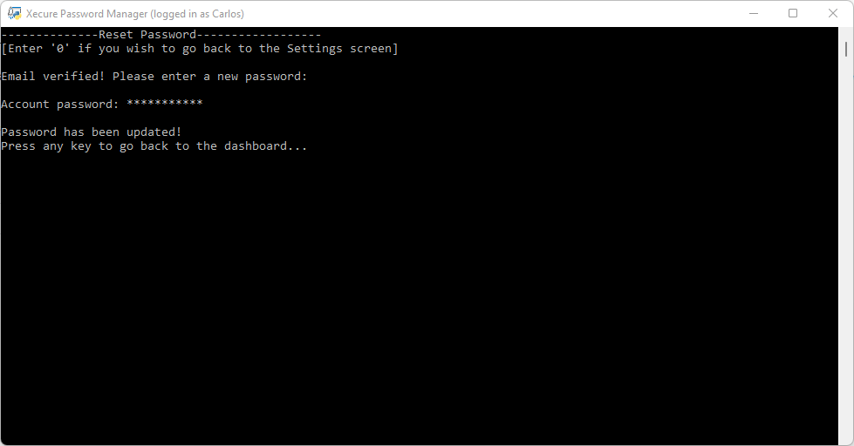

Figure 30: Resetting Account Password Screen

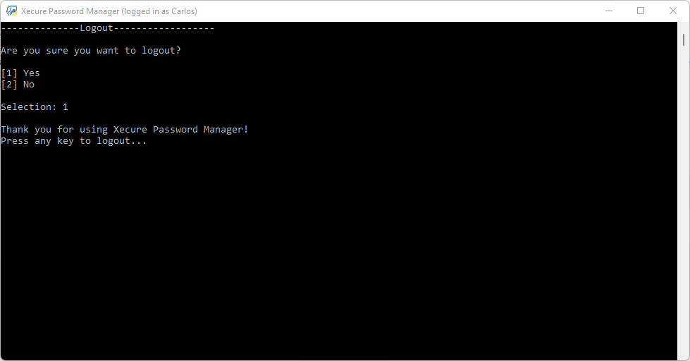

Figure 31: Logout Screen

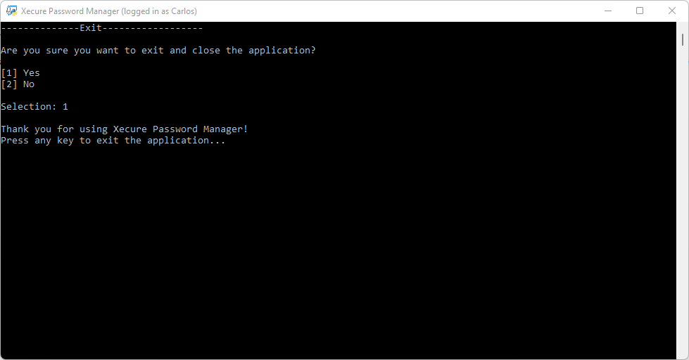

Figure 32: Exit Screen

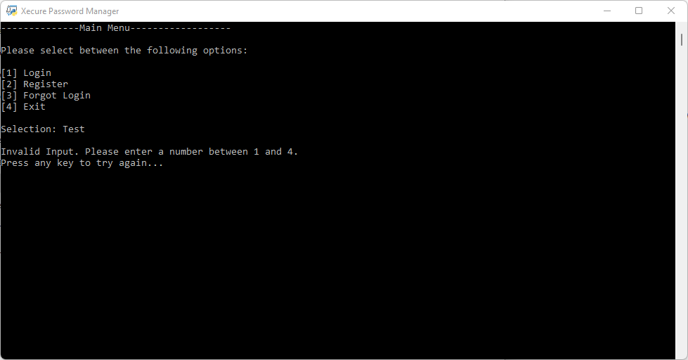

Figure 33: Main Menu Invalid Input

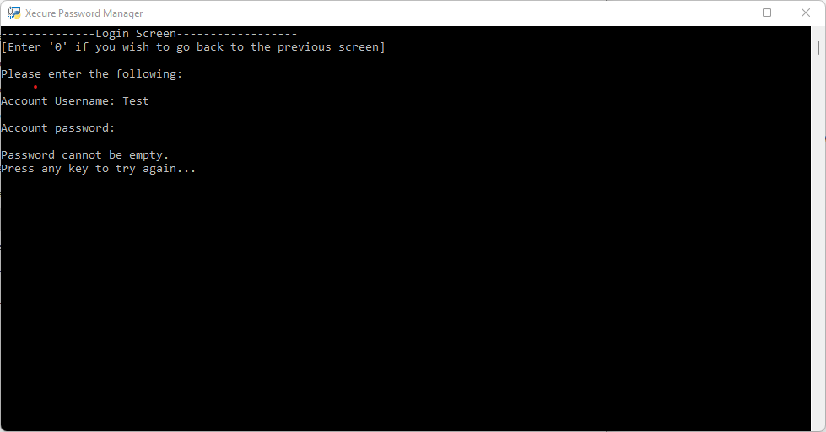

Figure 34: Invalid Login Attempt (Empty Password)

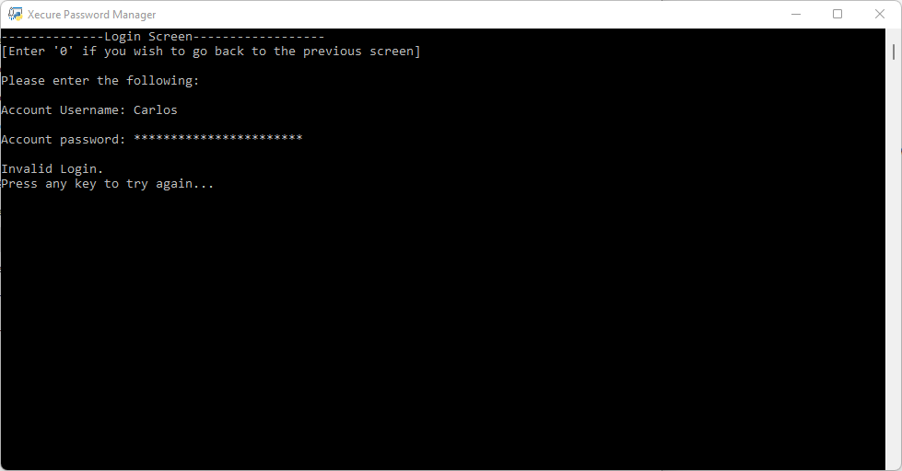

Figure 35: Invalid Login Attempt

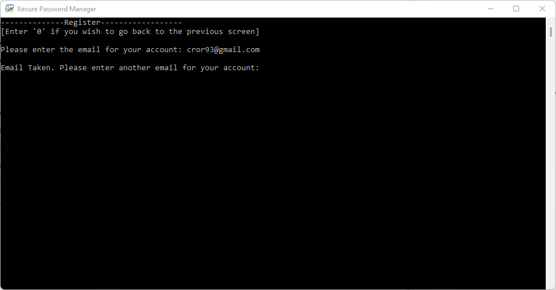

Figure 36: Register Screen Email Taken Error

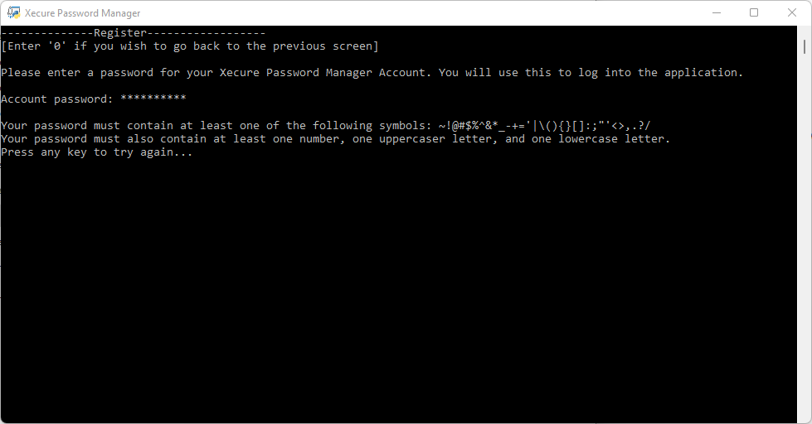

Figure 37: Register Weak Password Error

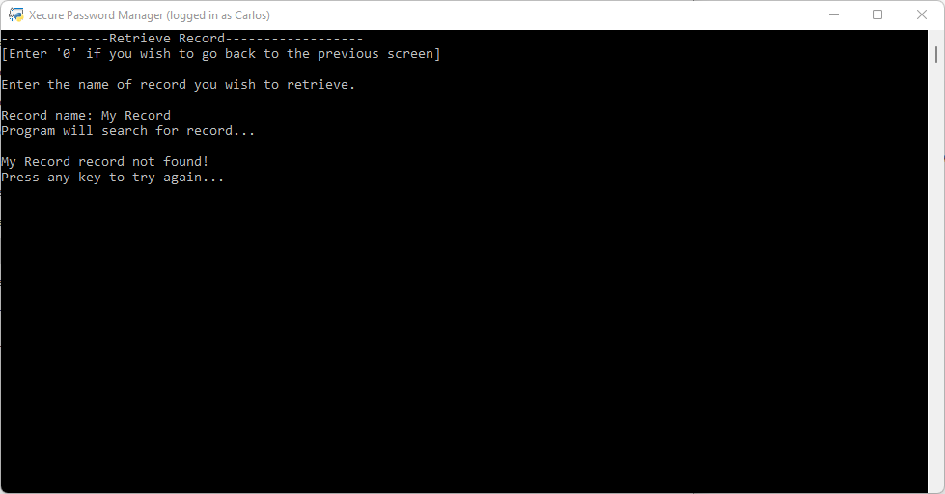

Figure 38: Retrieve Record – No Record Found Error

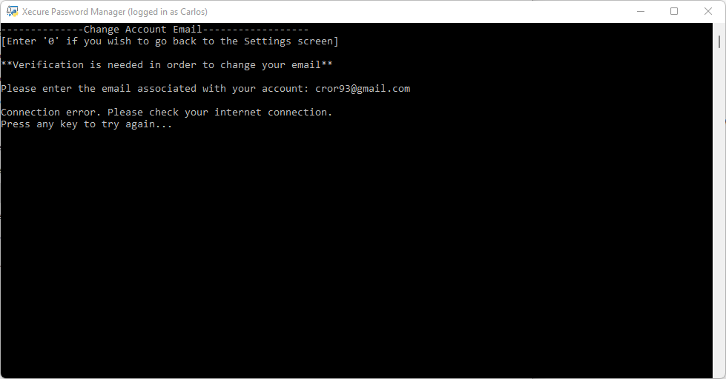

Figure 39: Change Account Email – Email Taken Error

**Test Plan**

The first step of the testing process involved creating test cases for the application. For a detailed look of the test cases please refer to the “Xecured Password Manager Test Cases” document. This document describes in detail the behavior of the application given an input. The tests cases were created through an iterative process of creating test cases to test the application, and then gathering feedback from volunteers. This process was repeated three times and the result was the current version of the “Xecured Password Manager Test Cases”.

The user feedback process involved finding volunteers to test the application for usability and errors. For this test three users were selected and each one of them represents a specific demographic (inexperienced, experience, and very experienced). All three volunteers were asked to perform the following steps:

Tasks:

1 – Use the Xecure Password Manager application to register and make an account.

2 – Log into the Xecure Password Manager application.

3 – Add two new records to your account. Use a randomly generated password for your first record. For your second record, enter your own password.

4 – Retrieve and display the information for one of your records.

5 – Retrieve and display the information of all your records.

6 – Update the password of one of your records, then retrieve and display it to the screen.

7 – Delete one of your records and then display all your records.

8 – Change your Master password, then log out and try to login with your new password.

9 – Delete all your records, and then try to display all of your records to the screen.

10 – Exit the application.

**Test Results**

Major findings for the usability tests:

1. Application needed a consistent way to back out of menus.
2. Remove User Id information.
3. Better description on verification emails needed.
4. The Delete Record options difficult to find.
5. Email addresses are case sensitive.

Major findings for the test cases tests:

1. Application does not sanitize clipboard if user force closes the application
2. Menu selections accept inputs with leading zeros.
3. Cannot properly exit application until the fifteen seconds of the clipboard are done.
4. Cannot properly of the application until the fifteen seconds of the clipboard are done.
5. Clipboard not sanitized if user force closes the application
6. Email addresses are case sensitive.

Fixes:

1. A “back” option was added to every screen, and input prompt.
2. Information about user ID, was being displayed but this bug was corrected.
3. Emails now contain a better description of what to do and why the email was sent.
4. The “Settings” option is now “Settings & Delete Records”. This will help users find the delete record options.
5. Application was updated to remove case sensitive emails.

The following findings were not corrected in the current version of the application:

* Menu selections accept inputs with leading zeros.
* Clipboard not sanitized if user force closes the application
* Cannot properly the exit application until the fifteen seconds of the clipboard are done.
* Cannot properly log out of the application until the fifteen seconds of the clipboard are done.

The reason why these findings were not corrected was due to the time constraint. These findings were found late in the testing phase and a fix would have required the testing to be re-done. The first finding does not affect the usability or security of the application and therefore it was identified as a low priority. The next update of the application will validate the input to make sure that inputs with leading zeros are not accepted. The other three findings could lead to the clipboard not being properly sanitized and this could be exploited by an attacker. The current structure of the application cannot prevent the user from force closing the application and thus cannot prevent this vulnerability as they are tied to the Windows command prompt. However, the risk could be mitigated by implementing a fix that stops the thread that contains the fifteen second countdown if the user exits or logs out of the application. This fix is a priority, and it will be implemented in the next version of the application.

**Challenges Overcome**

One of the biggest challenges was the time constraint. Due to financial reasons, I was forced to take the project design and project implementation during the same semester. This was very challenging as I had very little time to research and perform initial tests before I needed to decide on a project and begin its implementation. This also meant that I had I to stick with all of my decisions as I had no time to look for other alternatives. Another big challenge was using the python language as I had no experience with this programming language. I chose this as my project’s programming language because I had always wanted to learn python and using it to create my graduation project would give me the hands-on experience that I desired. The biggest challenge came from the encryption and decryption process. I had never used any encryption or decryption algorithms and understanding and applying the concepts of encoding and buffering were no easy task. I had many issues trying to encrypt and decrypt data from the database and this was by far the most time-consuming part of this project. After succeeding in encrypting and decrypting data from the database I had difficulties linking the data to users (since the data was encrypted). The solution to this problem took several weeks, but I was able to address it by giving every user a “user ID” that would be the link between their account and their encrypted data. This user ID is created from a hash that is created from the user’s account name and their password. After these challenges were solved, it was only a matter of fixing bugs and testing the application.

**Future Enhancements**

Due to the nature of Password Manager applications, it is important to maintain a plan to support and update the application. New security vulnerabilities are discovered everyday and with the advancements of computing, cracking passwords becomes much easier task every year. The features below are considered necessary for the success of the application and should be implemented to improve the usability and security of the Xecure application.

Future Updates:

* Email Validation – The current version of the application cannot validate that the entered email is a valid and working email. To improve the security of the application users should have to verify their email address before they can register or changer their email address.
* Better Input Validation – Better input validation will improve the security of the application, but this is a time-consuming task, and it requires continuous monitoring and updating.
* Better Master Password Policies – The current version of the application follows the basic guidelines of the NIST 800-63B. However, a stricter password policy should be created for the “master” password. This new policy should prevent users from using well known passwords, and previously used passwords.
* Stop Sleep Thread – The current version of the application cannot properly exit or logout users if the timer for the Sleep() thread has not finished. This fix is a priority and it will ensure that the Sleep() thread is stopped if a user tries to exit or logout of the application before the fifteen seconds are finished.
* Confirm Password/Email – The current version of the application only prompts the user to enter their email/password once. In a future update the user will be asked to enter their password/email in order to confirm the input. This will avoid users getting locket out due to typos.
* Additional Authentication Methods – Adding other authentication methods will improve the security of the application. Additional authentication methods can include one-time codes sent to the user’s phone, user security questions, and or others.
* Better Lockout – The current version of the application only closes the application after six failed login attempts. A feature that locks the account based on the username will be implemented. This will ensure that the locked user cannot login without verifying their account through a code sent to their email address.
* Password Generator Usage – The password generator was meant to be used throughout the menus that allow you to change/update your password but was removed due to bugs and time constraints. The option to use the password generator when changing a password will be added in the future.
* Reject Leading Zeros – The current version of the application accepts menu selections that have leading zeros (as long as the input is composed of only leading zeros and a valid integer at the end). A fix will be implemented to validate input that contains leading zeros and reject the input.
* GUI Version – A version that utilizes a graphical interface would make it easier to use and should be possible now that the foundation has been implemented.

**References**

Google. (2019, February). *Online Security Survey*. Google. Retrieved September 18, 2021, from https://services.google.com/fh/files/blogs/google_security_infographic.pdf.

Greig, J. (2020, July 29). *IBM finds cyberattacks costing companies nearly $4 million per breach*. TechRepublic. Retrieved September 18, 2021, from https://www.techrepublic.com/article/ibm-finds-cyberattacks-costing-companies-nearly-4-million-per-breach/.

Lord, N. (2020, September 29). *Uncovering password habits: Are users' password security habits improving? (infographic)*. Digital Guardian. Retrieved September 18, 2021, from https://digitalguardian.com/blog/uncovering-password-habits-are-users-password-security-habits-improving-infographic.